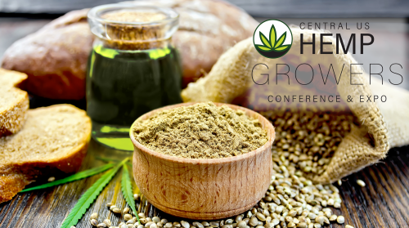
Support the movement that is happening in Madison Wisconsin February 26th & 27th 2018 at the Monona Terrace
Experts are coming in from all over the United States to teach you
- Proper growing practices for grain, fiber & CBD
- Ideal soil conditions
- Modifying existing equipment
- What genetics to grow to produce maximum yield
- Productions costs VS net yield
- Manufacturing for grain, fiber and CBD production
- Different manufacturing methods & end product uses
- FDA Requirements, labeling
- Laws of CBD and Hemp derived cannabinoids
- Science of CBD
- State and Federal laws
Exhibitors: Bish Enterprises . Power Zone . CW Hemp . Wisconsin Department of AG . Hemp Logic Greenfield Global . Taproot Farms . Hempstead Project Heart . Minnesota Hemp Farms, Inc . Agricultural Hemp Solutions . Wisconsin Farm Bureau . NORML . Doug Fine Book Signing
Let’s keep the Midwest moving forward to create a new culture of Industrial Hemp Entrepreneurs. See you at the show!
For More information go to www.centralushemp.com Call: 715-824-5666 E-Mail: melissa@boothboss.com

